ECE 6130 Big Data and Cloud Computing Spring 2019

Homework #3 Report

Name: Tianyu Yang

GW ID: G38878678

Date: 3/4/2019

Objective:

1. This homework is to use MapReduce function in Hadoop to run BFS algorithm
2. Try to use Colonial One machine to run nodes and edges with 1, 4, 8, 16

Procedure 1: Install Hadoop on Ubuntu

1. Install jdk on Ubuntu and configure the environment
2. Update the repositories

Sudo apt-get update

1. Start java installation

Sudo apt-get purge openjdk*

Sudo add-apt-repository ppa:webupd8team.java

Sudo apt-get update

Sudo apt-get install oracle-java8-installer

Java -version

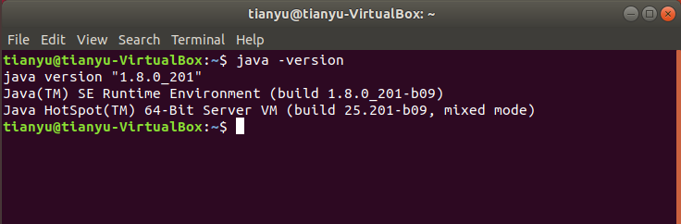

Sudo echo “export JAVA_HOME=/usr” >> /etc/profile

Source /etc/profile

1. Disable ipv6 since Hadoop does not support it that Hadoop support only ipv4

Sudo nano /etc/syssctl.conf

**Move to the end and append the code**

#Disable IPv6

Net.ipv6.conf.all.disable_ipv6 = 1

Net.ipv6.conf.default.disable_ipv6 = 1

Net.ipv6.conf.lo.disable_ipv6 = 1

**Then reboot the system**

Sudo reboot

1. Add a group for Hadoop

Sudo addgroup hadoopgroup

Sudo adduser -ingroup hadoopgroup tyuser

1. Install ssh

Sudo apt-get install ssh

Sudo systemctl enable ssh

Sudo systemctl start ssh

Su – tyuser

Ssh-keygen -t rsa -P “”

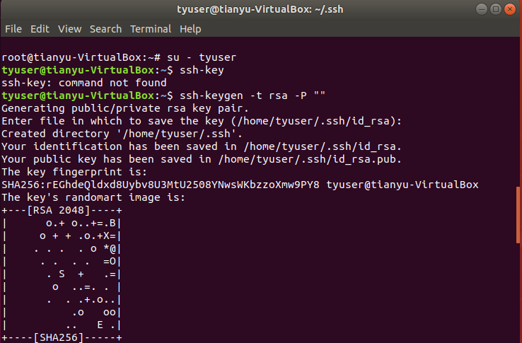

Cat /home/tyuser/.ssh/id_rsa.pub >> /home/tyuser/.ssh/authorized_keys

Cd .ssh/

Ls

Chmode 600 ./authorized_keys

Ls -l

Ssh-copy-id -i /home/tyuser/.ssh/id_rsa.pub localhost

Ssh localhost

Exit

1. Install Hadoop to Ubuntu
2. Download Hadoop package from Oracle website

Wget <http://mirror.fibergrid.in/apache/hadoop/common/hadoop-3.1.2/hadoop-3.1.2.tar.gz>

Tar -xvf Hadoop-3.1.2.tar.gz

Sudo mv ./hadoop-3.1.2 /usr/local

Sudo ln -sf /usr/local/Hadoop-3.1.2/ /usr/local/Hadoop

Sudo chown -R hduster:hadoopgroup /usr/local/Hadoop-3.1.2/

Su – tyuser

1. Configure the running environment for Hadoop

Nano ./.bashrc

**Add the code in the bottom of the file**

#Hadoop config

Export HADOOP_PREFIX=/usr/local/Hadoop

Export HADOOP_HOME=/usr/local/Hadoop

Export HADOOP_MAPRED_HOME=${HADOOP_HOME}

Export HADOOP_COMMON_HOME=${HADOOP_HOME}

Export HADOOP_HDFS_HOME=${HADOOP_HOME}

Export YARN_HOME=${HADOOP_HOME}

Export HADOOP_CONF_DI${HADOOP_HOME}/etc/Hadoop

#Native path

Export HADOOP_COMMON_LIB_NATIVE_DI${HADOOP_HOME}/lib/native

Export HADOOP_OPTS=”-Djava.library.path=$HADOOP_PREFIX/lib/native”

#Java path

Export JAVA_HOME=”/usr”

#OS Path

Export PATH=$PATH:$HADOOP_HOME/bin:$JAVA_HOME/bine:$HADOOP_HOME/sbin

**then**

source ./.bashrc

nano /usr/local.hadoop/etc/Hadoop/Hadoop-env.sh

**Add the code in the bottom of the file**

Export JAVA_HOME=”/usr”

1. Modify the xml file

Cd /usr/local/Hadoop/etc/hadoop

Nano core-site.xml

**Add the code in the bottom of the file(inside <configuration>)**

<property>

<name>fs.default.name</name>

<value>hdfs://localhost:9000<value>

</property>

**Similarly for hdfs-site-xml**

Name: dfs.replication

Value: 1

Name: dfs.name.dir

Value: file:/usr/local/Hadoop/hadoopdata/hdfs/namenode

Name: dfs.data.dir

Value: file:/usr/local/Hadoop/hadoopdata/hdfs/datanode

**Similarly for mapred-site-xml**

Name: mapreduce.framework.name

Value: yarn

**Similarly for yarn-site-xml**

Name: yarn.nodemanager.aux-services

Value: mapreduce_shuffle

**Then**

Hdfs namenode -format

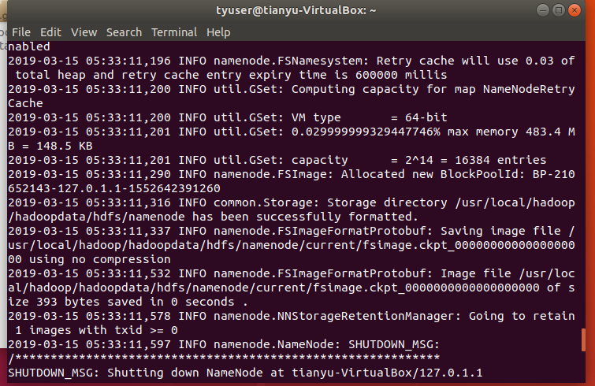

1. Run .sh file

Start-dfs.sh

Start-yarn.sh

Jps

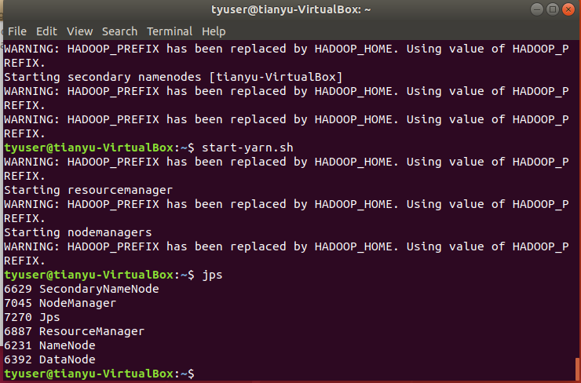

Procedure 2:

1. Introduction to Breadth-First Search (BFS)

Breadth-First Search is an iterated algorithm over graphs. Fronties advances from origin by one level with each pass

1. How to use MapReduce in BFS

Iterated passes through MapReduce – map some nodes, result includes additional nodes which are fed into successive MapReduce passes. The MapReduce method can advance the known frontier by one hop. To realize this parallel computing, the key element is independent PageRank computations in a given step. This parallelization requires to think about the minimum data partitions to transmit.

1. The running code is shown as below:

/*

*

* ECE 6130 Big Data and Cloud Computing

* Spring 2019

* Homework 3: BFS using MapReduce (Hadoop)

* Name: Tianyu Yang

* GW ID:G38878678

* Referenced from https://puffsun.iteye.com/blog/1905524

*

*/

**import** org.apache.hadoop.conf.Configuration;

**import** org.apache.hadoop.conf.Configured;

**import** org.apache.hadoop.fs.FileSystem;

**import** org.apache.hadoop.fs.Path;

**import** org.apache.hadoop.io.LongWritable;

**import** org.apache.hadoop.io.Text;

**import** org.apache.hadoop.mapreduce.Job;

**import** org.apache.hadoop.mapreduce.Mapper;

**import** org.apache.hadoop.mapreduce.Reducer;

**import** org.apache.hadoop.mapreduce.lib.input.FileInputFormat;

**import** org.apache.hadoop.mapreduce.lib.input.TextInputFormat;

**import** org.apache.hadoop.mapreduce.lib.output.FileOutputFormat;

**import** org.apache.hadoop.mapreduce.lib.output.TextOutputFormat;

**import** org.apache.hadoop.util.Tool;

**import** org.apache.hadoop.util.ToolRunner;

**import** java.io.BufferedReader;

**import** java.io.IOException;

**import** java.io.InputStreamReader;

**import** java.util.HashMap;

**public** **class** BFSMapReduce **extends** Configured **implements** Tool {

**public** **static** String *OUT* = "output";

**public** **static** String *IN* = "inputlarger";

**public** **static** **class** DijkstraMapper **extends** Mapper<LongWritable, Text, LongWritable, Text> {

**public** **void** map(LongWritable key, Text value, Context context)

**throws** IOException, InterruptedException {

//From slide 20 of Graph Algorithms with MapReduce (by Jimmy Lin, Univ @ Maryland)

//Key is node n

//Value is D, Points-To

//For every point (or key), look at everything it points to.

//Emit or write to the points to variable with the current distance + 1

Text word = **new** Text();

String line = value.toString();//looks like 1 0 2:3:

String[] sp = line.split(" ");//splits on space

**int** distanceAdded = Integer.*parseInt*(sp[1]) + 1;

String[] pointsTo = sp[2].split(":");

**for** (String distance : pointsTo) {

word.set("VALUE " + distanceAdded);//tells me to look at distance value

context.write(**new** LongWritable(Integer.*parseInt*(distance)), word);

word.clear();

}

//pass in current node's distance (if it is the lowest distance)

word.set("VALUE " + sp[1]);

context.write(**new** LongWritable(Integer.*parseInt*(sp[0])), word);

word.clear();

word.set("NODES " + sp[2]);//tells me to append on the final tally

context.write(**new** LongWritable(Integer.*parseInt*(sp[0])), word);

word.clear();

}

}

**public** **static** **class** DijkstraReducer **extends** Reducer<LongWritable, Text, LongWritable, Text> {

**public** **void** reduce(LongWritable key, Iterable<Text> values, Context context)

**throws** IOException, InterruptedException {

//From slide 20 of Graph Algorithms with MapReduce (by Jimmy Lin, Univ @ Maryland)

//The key is the current point

//The values are all the possible distances to this point

//we simply emit the point and the minimum distance value

String nodes = "UNMODED";

Text word = **new** Text();

**int** lowest = 10009;//start at infinity

**for** (Text val : values) {//looks like NODES/VALUES 1 0 2:3:, we need to use the first as a key

String[] sp = val.toString().split(" ");//splits on space

//look at first value

**if** (sp[0].equalsIgnoreCase("NODES")) {

nodes = **null**;

nodes = sp[1];

} **else** **if** (sp[0].equalsIgnoreCase("VALUE")) {

**int** distance = Integer.*parseInt*(sp[1]);

lowest = Math.*min*(distance, lowest);

}

}

word.set(lowest + " " + nodes);

context.write(key, word);

word.clear();

}

}

//Almost exactly from http://hadoop.apache.org/mapreduce/docs/current/mapred_tutorial.html

**public** **int** run(String[] args) **throws** Exception {

//http://code.google.com/p/joycrawler/source/browse/NetflixChallenge/src/org/niubility/learning/knn/KNNDriver.java?r=242

//make the key -> value space separated (for iterations)

getConf().set("mapred.textoutputformat.separator", " ");

//set in and out to args.

*IN* = args[0];

*OUT* = args[1];

String infile = *IN*;

String outputfile = *OUT* + System.*nanoTime*();

**boolean** isdone = **false**;

**boolean** success = **false**;

HashMap<Integer, Integer> _map = **new** HashMap<Integer, Integer>();

**while** (!isdone) {

Job job = **new** Job(getConf(), "Dijkstra");

job.setJarByClass(ParallelDijkstra.**class**);

job.setOutputKeyClass(LongWritable.**class**);

job.setOutputValueClass(Text.**class**);

job.setMapperClass(DijkstraMapper.**class**);

job.setReducerClass(DijkstraReducer.**class**);

job.setInputFormatClass(TextInputFormat.**class**);

job.setOutputFormatClass(TextOutputFormat.**class**);

FileInputFormat.addInputPath(job, **new** Path(infile));

FileOutputFormat.setOutputPath(job, **new** Path(outputfile));

success = job.waitForCompletion(**true**);

//remove the input file

//http://eclipse.sys-con.com/node/1287801/mobile

**if** (!infile.equals(*IN*)) {

String indir = infile.replace("part-r-00000", "");

Path ddir = **new** Path(indir);

FileSystem dfs = FileSystem.get(getConf());

dfs.delete(ddir, **true**);

}

infile = outputfile + "/part-r-00000";

outputfile = *OUT* + System.*nanoTime*();

//do we need to re-run the job with the new input file??

//http://www.hadoop-blog.com/2010/11/how-to-read-file-from-hdfs-in-hadoop.html

isdone = **true**;//set the job to NOT run again!

Path ofile = **new** Path(infile);

FileSystem fs = FileSystem.get(**new** Configuration());

BufferedReader br = **new** BufferedReader(**new** InputStreamReader(fs.open(ofile)));

HashMap<Integer, Integer> imap = **new** HashMap<Integer, Integer>();

String line = br.readLine();

**while** (line != **null**) {

//each line looks like 0 1 2:3:

//we need to verify node -> distance doesn't change

String[] sp = line.split(" ");

**int** node = Integer.*parseInt*(sp[0]);

**int** distance = Integer.*parseInt*(sp[1]);

imap.put(node, distance);

line = br.readLine();

}

**if** (_map.isEmpty()) {

//first iteration... must do a second iteration regardless!

isdone = **false**;

} **else** {

//http://www.java-examples.com/iterate-through-values-java-hashmap-example

//http://www.javabeat.net/articles/33-generics-in-java-50-1.html

**for** (Integer key : imap.keySet()) {

**int** val = imap.get(key);

**if** (_map.get(key) != val) {

//values aren't the same... we aren't at convergence yet

isdone = **false**;

}

}

}

**if** (!isdone) {

_map.putAll(imap);//copy imap to _map for the next iteration (if required)

}

}

**return** success ? 0 : 1;

}

**public** **static** **void** main(String[] args) **throws** Exception {

System.*exit*(ToolRunner.run(**new** ParallelDijkstra(), args));

}

}

1. Run a sample BFS tree and obtain the result.

Input data:

1 0 2:3:

2 10000 1:4:5:

3 10000 1:

4 10000 2:5:

5 10000 2:4:

Output shell result:

03/03/19 20:08:03 INFO input.FileInputFormat: Total input paths to process : 1

03/03/19 20:09:04 INFO mapred.JobClient: Running job: job_201307131656_0001

03/03/19 20:09:05 INFO mapred.JobClient: map 0% reduce 0%

03/03/19 20:10:05 INFO mapred.JobClient: map 100% reduce 0%

03/03/19 20:15:13 INFO mapred.JobClient: map 100% reduce 100%

03/03/19 20:15:16 INFO mapred.JobClient: Job complete: job_201307131656_0001

03/03/19 20:15:16 INFO mapred.JobClient: Counters: 32

03/03/19 20:15:16 INFO mapred.JobClient: File System Counters

03/03/19 20:15:16 INFO mapred.JobClient: FILE: Number of bytes read=183

03/03/19 20:15:16 INFO mapred.JobClient: FILE: Number of bytes written=313855

03/03/19 20:15:16 INFO mapred.JobClient: FILE: Number of read operations=0

03/03/19 20:15:16 INFO mapred.JobClient: FILE: Number of large read operations=0

03/03/19 20:15:16 INFO mapred.JobClient: FILE: Number of write operations=0

03/03/19 20:15:16 INFO mapred.JobClient: HDFS: Number of bytes read=173

03/03/19 20:15:16 INFO mapred.JobClient: HDFS: Number of bytes written=53

03/03/19 20:15:16 INFO mapred.JobClient: HDFS: Number of read operations=2

03/03/19 20:15:16 INFO mapred.JobClient: HDFS: Number of large read operations=0

03/03/19 20:15:16 INFO mapred.JobClient: HDFS: Number of write operations=1

03/03/19 20:15:16 INFO mapred.JobClient: Job Counters

03/03/19 20:15:16 INFO mapred.JobClient: Launched map tasks=1

03/03/19 20:15:16 INFO mapred.JobClient: Launched reduce tasks=1

03/03/19 20:15:16 INFO mapred.JobClient: Data-local map tasks=1

03/03/19 20:15:16 INFO mapred.JobClient: Total time spent by all maps in occupied slots (ms)=38337

03/03/19 20:15:16 INFO mapred.JobClient: Total time spent by all reduces in occupied slots (ms)=159310

03/03/19 20:15:16 INFO mapred.JobClient: Total time spent by all maps waiting after reserving slots (ms)=0

03/03/19 20:15:16 INFO mapred.JobClient: Total time spent by all reduces waiting after reserving slots (ms)=0

03/03/19 20:15:16 INFO mapred.JobClient: Map-Reduce Framework

03/03/19 20:15:16 INFO mapred.JobClient: Map input records=5

03/03/19 20:15:16 INFO mapred.JobClient: Map output records=20

03/03/19 20:15:16 INFO mapred.JobClient: Map output bytes=383

03/03/19 20:15:16 INFO mapred.JobClient: Input split bytes=112

03/03/19 20:15:16 INFO mapred.JobClient: Combine input records=0

03/03/19 20:15:16 INFO mapred.JobClient: Combine output records=0

03/03/19 20:15:16 INFO mapred.JobClient: Reduce input groups=5

03/03/19 20:15:16 INFO mapred.JobClient: Reduce shuffle bytes=179

03/03/19 20:15:16 INFO mapred.JobClient: Reduce input records=20

03/03/19 20:15:16 INFO mapred.JobClient: Reduce output records=5

03/03/19 20:15:16 INFO mapred.JobClient: Spilled Records=40

03/03/19 20:15:16 INFO mapred.JobClient: CPU time spent (ms)=3970

03/03/19 20:15:16 INFO mapred.JobClient: Physical memory (bytes) snapshot=240209920

03/03/19 20:15:16 INFO mapred.JobClient: Virtual memory (bytes) snapshot=2276737024

03/03/19 20:15:16 INFO mapred.JobClient: Total committed heap usage (bytes)=101519360

Procedure 3

**Result analysis**

The input tree has three levels and five nodes. The total time spent by all maps in occupied slots is 38337 ms. The total time spent by all reduces in occupied slots is 159310 ms. For the MapReduce, the input records is 5 and the output records is 20. The CPU time spent is 2290 ms.